Worcester Polytechnic Institute

Production of a Clay Oven at WPI

Class/Term: MIS576-S24-S01

Professor Vance “Smoky” Wilson

Team 2:

Andrew McClain, Hoang Nguyen, Varun Gampa, and Jayesh HaryaniTable of Contents

Project Overview Statement: 3

Project Executive Summary 4

Project Integration Management 5

Project Scope Management 7

Project Schedule Management 12

Project Cost Management 13

Project Quality Management 15

Project Resource Management 17

Project Risk Management 19

Project Communications Management 25

Planning Procurements 26

Project Stakeholder Management 27

Project Site Location 30

Project Design Documents 32

# Project Overview Statement:

|  |  |  |  |
| --- | --- | --- | --- |
| **Project Overview Statement** | **Project Name:**  A Clay Oven for WPI (Worcester Polytechnic Institute) | **Project No.**  MIS-576-S24-S01-Team2 | **Project Manager:**  Andrew McClain |
| **Problem/Opportunity:**  Clay ovens are used around the world as a tool for cooking foods of many varieties. There will be a clay oven built for WPI, and this project is part of a competition for groups in MIS-576-S24 to develop the project management plan for the construction of this clay oven. | | | |
| **Goal:**  The goal of this project is to successfully develop a project management plan to produce a clay oven at WPI. This will carefully go over the needs for each step of its construction, to ensure it can be used for its intended use by the WPI stakeholders. | | | |
| **Objectives:**   1. Construct the plan for an oven to be built at WPI. 2. Follow a clearly defined schedule of the tasks from initiation, to planning, to execution, to monitoring and controlling, to closure, and to project review. 3. Acquire the necessary approvals (governmental and by WPI) to build the oven. 4. Ensure team members are properly trained for the tasks involved in this project. 5. Ensure the oven is in a safe and desirable location on campus. 6. Ensure the oven meets all the measurable success criteria. 7. Build a shell of non-commercial earth products. 8. Construct an oven that has the structural integrity to last at least 5 years | | | |
| **Success Criteria:**   1. The oven is accepted by the client, Vance “Smoky” Wilson 2. The oven can successfully bake 2 10” round pizzas or one 25 lb. turkey. 3. The oven must burn seasoned hardwood to over 800°F 4. The oven is constructed and ready for use no later than November 1, 2024 | | | |
| Assumptions, Risks, Checks:   1. Student breaks, including spring and summer break, may affect the planning or construction of the oven. 2. Safety risks: including during construction and post-construction during use of the oven on campus (fire hazards, etc.). 3. Legal Risks: ensuring the proper approvals from both governmental bodies and the WPI campus. | | | |
| **Prepared by:**  Andrew McClain | **Date:**  16Mar24 | **Approved By:**  Smoky | **Date:**  18Mar24 |

# Project Executive Summary

Over the course of the project the design of the clay oven has expanded past the initial scope of the project. These features were included to support the use of the clay oven:

* Counterspace
  + A counterspace located in front of the clay oven can be used to prepare dishes such as pizza and turkey. It could also be used for placing tools during the clay oven, such as a pizza peel or/and the oven cover.
* Wood and Tool Storage Area
  + In building the foundation / base for the clay oven there was an easy opportunity to build a storage area to house tools and firewood.
  + Having a designated area makes the oven easier to use. Novices would need to plan less when using the clay oven.
* Structure Surrounding the Oven
  + The structure consists of a roof, 2x4 framing and cement foundation acts to protect the clay oven from elements such as debris, rain, and snow.
  + This should help reduce the amount of maintenance for repairing the oven.
* Flue and Valve
  + For burning firewood, the flue and valve help control the flow of oxygen, letting the firewood burn faster, whilst redirecting smoke out through the vent/flue.
  + The valve can be used to help regulate the temperature of the oven during burning, baking, and cooking.
* Scheduling
  + The scheduling section of the Clay Oven Project outlines a comprehensive plan for the timely and efficient execution of all project activities. The main goal of this scheduling approach is to ensure that the clay oven's construction and implementation proceeds smoothly, meeting quality standards while adhering to budgetary and timeline constraints.
  + By adhering to the outlined schedule, the team can effectively coordinate efforts and overcome challenges, ensuring the successful completion of the clay oven project.
* Training
  + Training initiatives ensure team competence in critical areas such as safety, construction, and software utilization, aligning with project milestones.
  + Training session for project management was completed by Andrew, CAD software by Varun, safety compliance by Hoang, and supply chain management by Jayesh.

# Project Integration Management

Change 1: Adding Text Explanations

1. Submit Change Request:
   1. Smoky requested the following change: “In every major section include a text explanation sufficient to introduce the section's contents to readers who have no prior exposure with clay ovens or the design competition.”
2. Review Change Request:
   1. Our team has agreed to make the change to our Milestone 2.
3. Request Impact Study:
   1. n/a- the impact is clear from Smoky’s comment.
4. Review Impact Study:
   1. Not including the text explanations makes it difficult for readers who have no prior knowledge of clay ovens to understand the content of the project. Therefore, it is essential that this is added.
5. Change Approved for Implementation
   1. Our team has agreed to make the change to our Milestone 2

Change 2: Update to Stakeholder Focus

1. Submit Change Request:
   1. The client proposed a change to refine stakeholder management based on an updated stakeholder list.
2. Review Change Request:
   1. Need to prioritize stakeholders and select ones who have a major impact on the business value.
3. Request Impact Study:
   1. An assessment of the impact of this change on project communication, decision-making, and overall stakeholder engagement is necessary.
4. Review Impact Study:
   1. Reduced complexity in stakeholder interactions.
   2. Streamlined communication channels.
   3. More focused engagement with essential stakeholders.
5. Change Approved for Implementation:
   1. The project team agrees to implement the refined stakeholder management plan to optimize project communication and alignment with key stakeholders.

Change 3: Addition of a Flue to the Oven Structure

1. Submit Change Request
   1. Andrew requested a change to the design of V1.0 of the clay oven. He requested to add a vent and a flue to the design.
2. Review Change Request
   1. During one of our meetings, we discussed the idea and how it would impact the project.
3. Request Impact Study
   1. Both Andrew and Hoang looked discussed impact
4. Review Impact Study
   1. Two additional hours would be added to change the CAD model and documentation.
   2. This would improve novice user experience.
   3. Changes in scope of the project
   4. Minimal impact in instructing novices how to use a flue.
5. Change Approved for implementation.
   1. Agreed to make the change by milestone two.

Change 4: Change Order for the Brochure (Change Order 0001)

1. Submit Change Request:
2. Smoky requested the following change: “Distribute information, by creating an informational brochure which may be placed wherever you feel is the most appropriate location in your overall document.”
3. Review Change Request:
4. Our team has agreed to make the change to our Milestone 2.
5. Request Impact Study:
6. Varun would have a look at it and try to produce implications which would be of benefit to the stakeholders.
7. Review Impact Study:
8. Including an information brochure would help interested people know about the details of clay oven easily and would also assure them that safety of use has been considered.
9. Change Approved for Implementation
10. Our team has agreed to make the change to our Milestone 2

# Project Scope Management

The role of scope management is to define the requirements of the project based on our client. We are taking those requirements and turning them into clear success criteria for the team. Scope management also ensures the team can deliver. That means validating the scope, and seeing how the project scope changes due to scope change requests.

We go over the current requirement breakdown structure, validation of the scope, and controlling the scope of the project.

**Define Scope**

Plan the construction of a clay oven on WPIs campus that is built up to legal codes, within legal requirements, is safe to use, and can successfully cook 2 10’ pizzas or 1 25lb. turkey simultaneously. The oven must also heat seasoned hardwood quickly up to 800°F while being easy and safe to use for the WPI community, including teachers and students that may be novices in the use of clay ovens.

**RBS Overview**

The RBS looks at the project's requirements and helps break it down into manageable pieces for the team, in terms of physical deliverables.

For this figure, anything in green means that the task is complete and considered. Anything in blue means the task has not been completed. Although this color coding is not necessary for the RBS, it is useful for looking at the progress of the project.

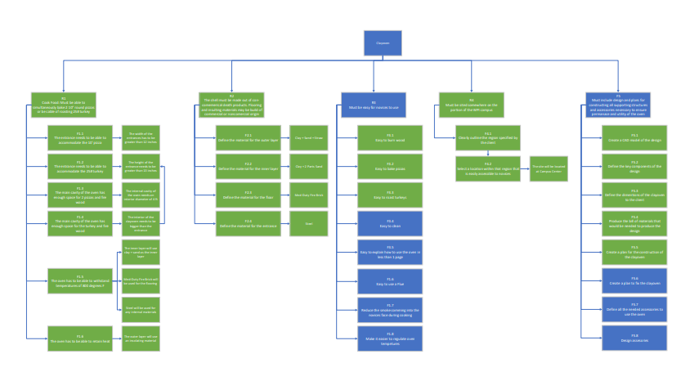

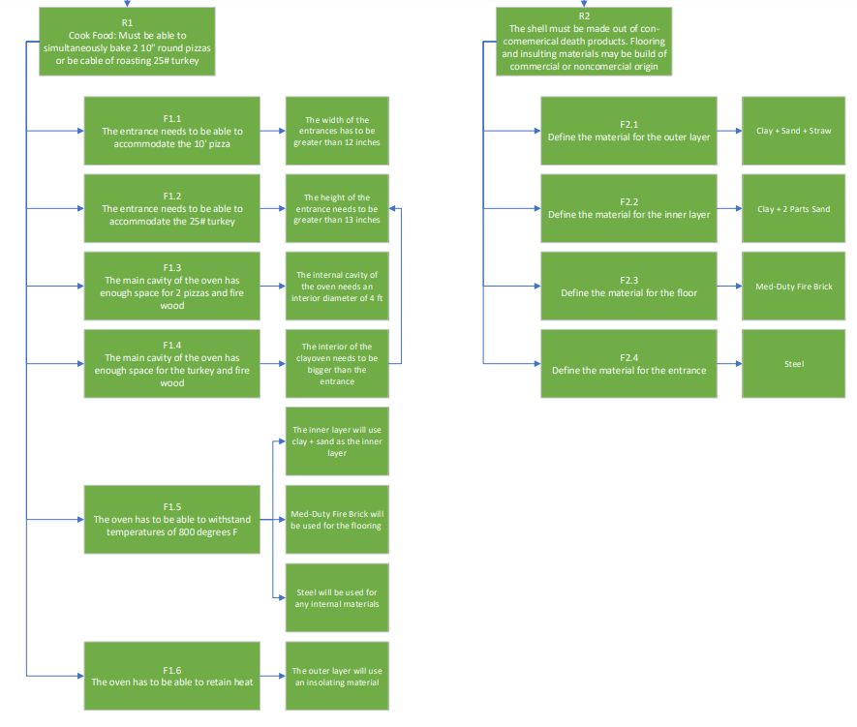

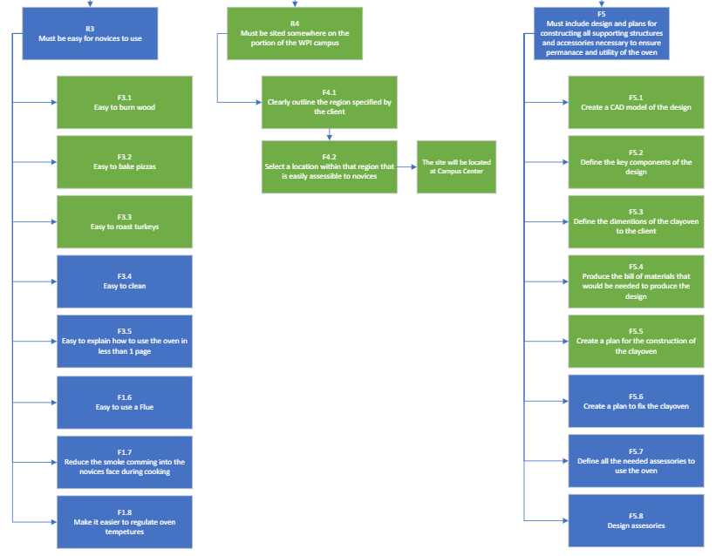

**Validate Scope**

Looking back at the initial scope, we seem to be missing details/features as to how to keep the clay oven lasting for roughly 5 years. Besides that, missing detail, the remaining requirements are being satisfied.

For the next milestone, that last requirement will be added.

**Control Scope**

2 change requests have impacted the scope:

* Defining the novice target users as WPI students
* Adding a Flue to the design

Both requests have slightly changed the scope of the project. Since the target stakeholders are WPI students, we are choosing sites easily assessable for these students. This would also affect the user instructions that we would need to construct. Since these features have not been created, this change doesn’t delay our deliverable.

Adding flue to the design does affect multiple areas of the project. This feature is being added to help make regulating the temperature easier for our users. However, since the request was made after our prototype, it will affect our CAD model and plans to smoke. It will also affect construction.

# Project Schedule Management

* The project kickoff date is set as 4/4/2024.
* The planning and design phases are scheduled to align with the building of the plan throughout the semester.
* In this schedule, we plan to start the execution once the class is over, as the project has been approved by Smoky and our entire plan has been constructed by the completion of Milestone 3.

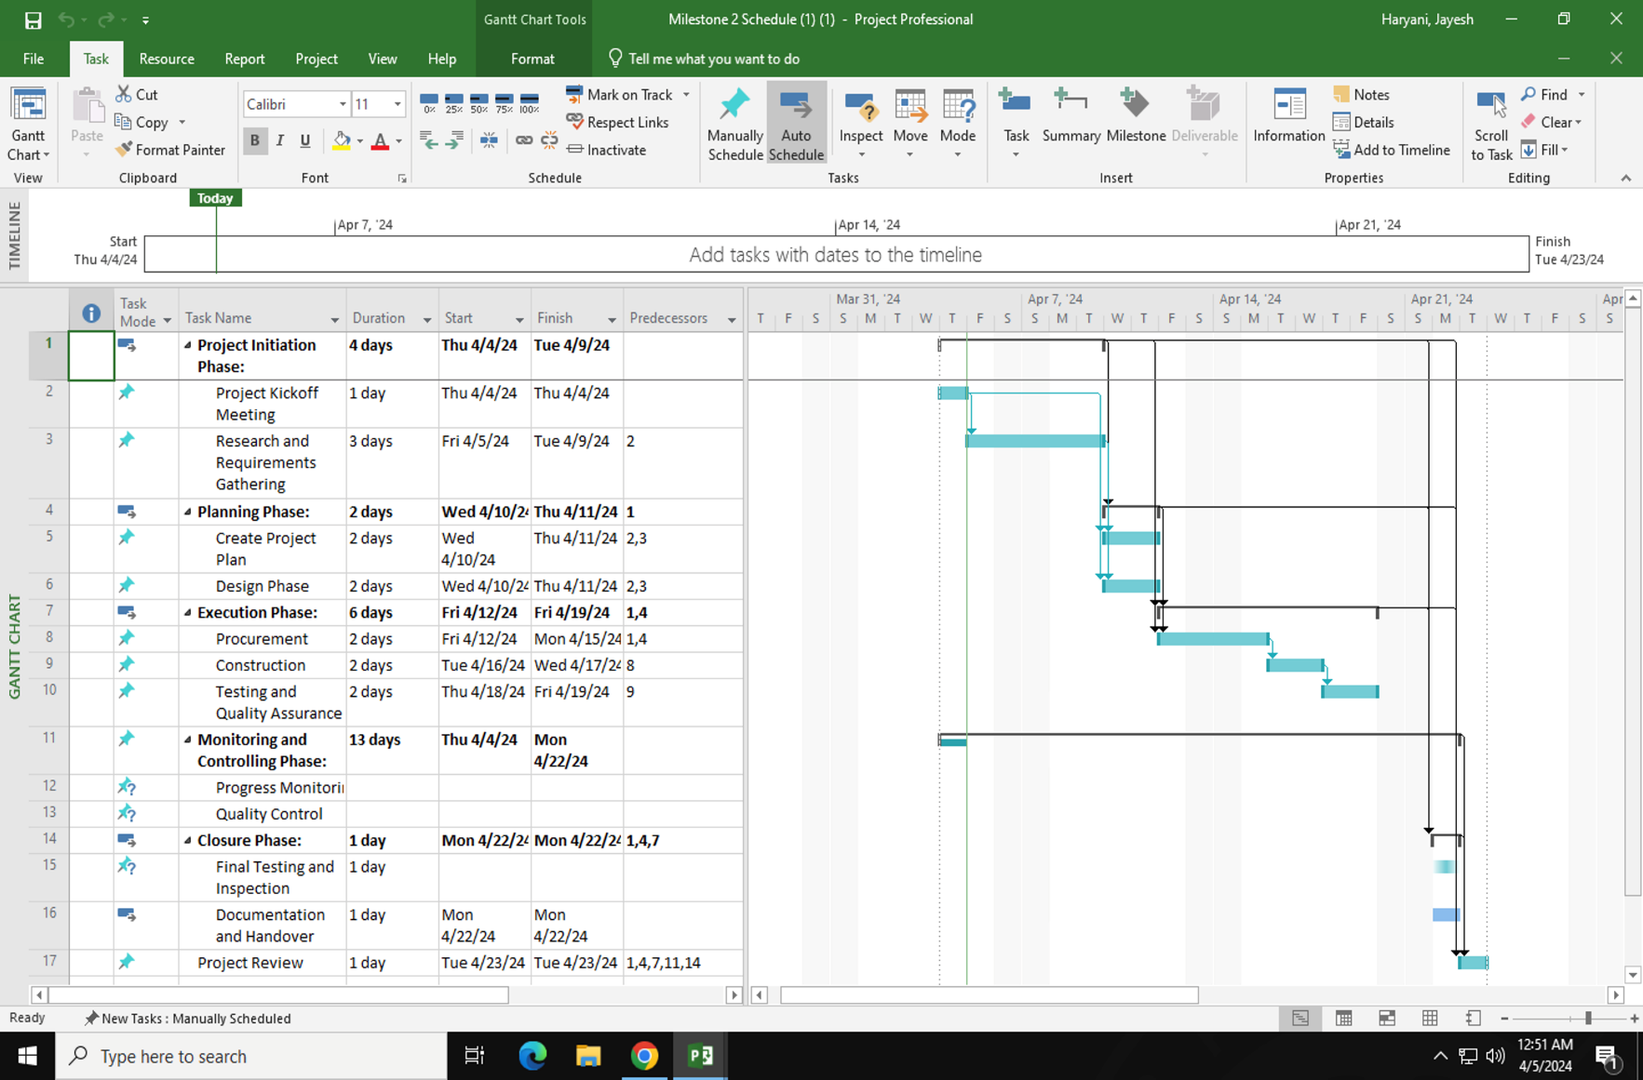

# Project Cost Management

One concern for cost management is the cost of the project. Here we go over the approximate material cost of the clay oven. Please refer to design documentation the materials being used. Please note that the material cost is suspectable to changes for milestone 3. There are additional costs listed within the “Project Resource Management” section associated with training.

Cost of contractor - $998

Cost of Maintenance - $173

**Material Cost**

|  |  |  |  |  |  |
| --- | --- | --- | --- | --- | --- |
| Notes | Material | Supplier | Unit Cost | Units | Cost |
|  | Clay | -- | -- | -- | 0.00 |
|  | Straw | -- | -- | -- | 0.00 |
|  | Cement | [Home Depot](https://www.homedepot.com/p/Quikrete-60-lb-Concrete-Mix-110160/100318478) | 4.54 | 2 | 9.08 |
|  | Sand | -- | -- | -- | 0.00 |
|  | Newspaper | -- | -- | -- | 0.00 |
|  | Core Concrete Block  8’8’16’ | [Lowe’s](https://www.lowes.com/pd/Common-8-in-x-8-in-x-16-in-Actual-7-625-in-x-7-625-in-x-15-625-in-Standard-Cored-Concrete-Block/3608978?cm_mmc=shp-_-b-_-prd-_-pro-_-ggl-_-LIA_BDM_000_PRO-_-3608978-_-local-_-0-_-0&gad_source=1&gclid=Cj0KCQjw2a6wBhCVARIsABPeH1tNfhqsCi760slvuYqBflK4aJUDu-EDjFv4inDHqFKXnigOYjEUJRMaAjUPEALw_wcB&gclsrc=aw.ds) | $2.33 | 147 | 342.51 |
|  | Concrete Brick  7.75’x2.25’x3.75’ | [Home Depot](https://www.homedepot.com/p/7-3-4-in-x-2-1-4-in-x-3-3-4-in-Concrete-Brick-25100130/100350234?source=shoppingads&locale=en-US&pla&mtc=SHOPPING-BF-CDP-GGL-D22-022_009_CONCRETE-NA-NA-NA-PMAX-NA-NA-NA-NA-NBR-NA-NA-NEW-NA&cm_mmc=SHOPPING-BF-CDP-GGL-D22-022_009_CONCRETE-NA-NA-NA-PMAX-NA-NA-NA-NA-NBR-NA-NA-NEW-NA-71700000112622853--&gad_source=1&gclid=Cj0KCQjw2a6wBhCVARIsABPeH1s8joFQWkvtopmyyBGI4XMW-zWcK6hnyqpKO_v5ctcHcQPVvjJCBrIaAsLAEALw_wcB&gclsrc=aw.ds) | $0.78 | 0 | 0 |
| [N1](https://www.fornobravo.com/pompeii-oven/brick-primer/) | Medium-Duty Fire Bricks  9’x4.5x1.25’ | [Home Depot](https://www.homedepot.com/p/HY-C-9-in-x-4-1-2-in-x-1-1-4-in-Medium-duty-Firebricks-3-per-Box-HTFB-R3/314578331?g_store=&source=shoppingads&locale=en-US&pla&mtc=SHOPPING-BF-CDP-GGL-D28I-028_022_GRILLS-NA-MULTI-NA-PMAX-NA-NA-NA-NA-NBR-NA-NA-NA-PMAX_SHP&cm_mmc=SHOPPING-BF-CDP-GGL-D28I-028_022_GRILLS-NA-MULTI-NA-PMAX-NA-NA-NA-NA-NBR-NA-NA-NA-PMAX_SHP-71700000113461774--&gad_source=1&gclid=Cj0KCQjw2a6wBhCVARIsABPeH1tCo0LfHsWmaVwYRtzTlykeSZIF45sk-xDLwMC0aC7b9QEe-EHYLIIaAg8HEALw_wcB&gclsrc=aw.ds) | $17.69/3 | 136 | 801.95 |
| [N2](https://buntyllc.com/high-temperature-metals/) | Stainless Steel Sheet 12”x24”x3/16” (ID: 9524K14) | [McMaster](https://www.mcmaster.com/products/sheet-metal/tight-tolerance-wear-resistant-410-stainless-steel/) | 835.77 | 2 | 1671.54 |
| N3 | Wood Sheets 0.75”x4’x8’ | [Home Depot](https://www.homedepot.com/p/3-4-in-x-4-ft-x-8-ft-Ground-Contact-Pressure-Treated-Pine-Performance-Rated-Sheathing-Plywood-106128/206971071) | 52.88 | 9 | 475.92 |
| N3 | Wood 2x4x12 | [Home Depot](https://www.homedepot.com/p/WeatherShield-2-in-x-4-in-x-12-ft-1-Ground-Contact-Pressure-Treated-Lumber-1001787124/207096351) | 8.38 | 6 | 50.28 |
| N3 | Wood 2x4x10 | [Home Depot](https://www.homedepot.com/p/WeatherShield-2-in-x-4-in-x-10-ft-1-Ground-Contact-Pressure-Treated-Lumber-1001787123/207096349) | 6.68 | 12 | 80.16 |
|  | Chimney Cap | [Home Depot](https://www.homedepot.com/p/VEVOR-Chimney-Cap-6-in-304-Stainless-Steel-Round-Roof-Rain-Cap-11-81-in-Increased-Caps-for-Vent-Cover-Outside-Silver-YXYCMYSBXGZDGEH55V0/328790736) | 39.99 | 1 | 39.99 |
|  | Flue Valve | [Home Depot](https://www.homedepot.com/p/DuraVent-DVL-6-in-Adapter-Damper-Section-in-Black-6DVL-ADWD/205544511) | 61.40 | 1 | 61.40 |
|  | Pizza Peel | [Amazon](https://www.amazon.com/Aluminum-Paddle-Detachable-Leather-overall/dp/B07FN611HD/ref=asc_df_B07FN611HD/?tag=hyprod-20&linkCode=df0&hvadid=272009130200&hvpos=&hvnetw=g&hvrand=5013420862626420058&hvpone=&hvptwo=&hvqmt=&hvdev=c&hvdvcmdl=&hvlocint=&hvlocphy=9001848&hvtargid=pla-490358263636&psc=1&mcid=d122faa9912c38edafd09b0dc4cdfab8&gclid=CjwKCAjww_iwBhApEiwAuG6ccHs-cUzUGXgo3hVQFH09IN-ZLjpCsBX2yoJdUCv_9s3AE9g0R6anxhoCR1EQAvD_BwE) | 21.95 | 1 | 21.95 |

Notes: N3 – The wood chosen here is designed for outdoor usage.

# Project Quality Management

The quality management program for the clay oven construction will include the quality management surrounding the raw materials, construction procedures, and functionality. The oven needs to be produced to a high enough standard to allow for safe and intended use. In addition, producing an oven of high quality would mean that the oven fits the client’s requirements, is delivered on time, within budget, and according to specification. The quality management program will include the following three processes:

1. Quality Planning Process
2. Quality Assurance Process
3. Quality Control Process

The quality requirements during the planning process were derived from the “Group Project Instructions” document and scope management section of Project Milestone 1.

Quality Planning Process:

* The Clay Oven must be accepted by our client, Vance “Smoky” Wilson.
* The oven must be made of materials that must be safely able to burn seasoned hardwood to quickly heat to over 800°F and be able to retain heat.
* The shell must be built of non-commercial earth products.
* The oven must be capable of simultaneously baking 2 10” round pizzas or be capable of roasting a 25-pound turkey.
  + The entrance must be large enough to fit these food items through.
  + The inside must be large enough to accommodate these food items.
* The oven must be easy for novices to use.
* The oven must be sited somewhere on the portion of the WPI campus that is bounded by Park Avenue, Salisbury Street, Boynton Street, and Institute Road, or within Institute Park.
* Must include design of and plans for constructing all supporting structures and accessories necessary to ensure permanence and utility of the oven.
* Must include design models, production prototypes, and any other proofs-of-concept.
* Plan for construction to be completed to ensure the first use of the oven is no later than November 1, 2024

Quality Assurance Process:

* A Project Overview Statement (P.O.S.) was developed by our team and submitted to the client, Smoky.
* Define which materials will be used to assure the quality standards are met (refer to Material Cost section above)
* The entrance to the clay oven will be 14 inches wide and 15.41 inches tall, to accommodate the entry of necessary food items.
* An instruction manual will be produced and provided to end-users to make it easier for novices to use.
  + Instructions on burning wood, baking common foods, roasting common foods, and cleaning.
* Surveys will be conducted by our stakeholder manager, Varun, to ensure that the oven is easy to use and meets the needs of stakeholders at WPI.
* The clay oven is planned to be built in Institute Park.
* Our team designer and planner, Hoang, will coordinate with our team scheduler, Jayesh, to ensure the proper materials are available in a timely manner for proper construction.
* Our team designer and planner, Hoang, will provide models and prototypes along the way for approval by the team and the client.
* Our scheduler, Jayesh, will use Microsoft Project to build a comprehensive schedule to ensure intermediate deadlines are met to meet the final deadline of November 1st.

Quality Control Process:

* Smoky has approved the Project Overview Statement, so the team has a clear understanding of the project overview and what needs to be done to meet the client’s needs.
* Materials that meet the necessary specifications have been decided upon. High quality vendors will be used.
* The oven will be built to the necessary size requirements.
* The instruction manual and surveys will be constantly monitored for feedback and adjustment.
* The oven will be built in Institute Park.
* Materials will be purchased in a timely manner.
* Comments on the prototype will be assessed and applied to future versions of the clay oven until the final model is decided upon.
* The materials and final clay oven model will be used to create the oven in a timely manner following the schedule that has been pre-defined.

# Project Resource Management

To make sure that the clay oven project is delivered on time, it is important to estimate the activity resources required. This would ensure timely completion of the project with fewer iterations. As we had divided the tasks amongst the 4 members overlooking the entire project, the resources are also split among them. Hence the resources to assess would be material handling, tools, labor, team collaborations events, training exercises, software.

**TOOLS:**

The tools necessary for construction, including shovels, trowels, mixing equipment, and any specialized tools for shaping and finishing the clay oven, will be evaluated. Accessibility and availability of tools will be considered to ensure smooth progress of construction activities.

**LABOR:**

**Mixing Process:** Labor will be required for the mixing of clay and sand, a critical process in preparing the raw materials for constructing the oven. Skilled individuals will be allocated to ensure the proper ratio and consistency of the clay mixture.

**Grass Mixing:** m.

**Construction:** Laborers will play a vital role in constructing the oven, including setting up the base and covering. Their expertise in masonry and construction will ensure the structural integrity and durability of the oven.

**Artistic Design:** Towards the final stages of construction, an artist will be enlisted to design intricate patterns or artwork on the outer shell of the clay oven. This artistic touch will enhance the aesthetic appeal of the oven and contribute to its uniqueness.

**SOFTWARE:**

**Fusion 360** will be utilized for creating a detailed 3D model of the clay oven, facilitating better planning and visualization of the construction process. Team members will ensure proficiency in using Fusion 360 to optimize design and construction workflows.

**MS Project** will be employed for project scheduling, task management, and resource allocation. Team members will leverage MS Project to create Gantt charts, track progress, and manage project timelines effectively.

**TEAM COLLABORATION EVENT:**

Collaboration events among team members will be organized to foster an environment of open communication, idea sharing, and mutual support. Regular team meetings and check-ins will be scheduled to discuss progress, address challenges, and provide updates on project tasks.

**TRAINING EXERCISES:**

* Training sessions and exercises will be conducted to enhance the skills and knowledge of team members related to project requirements. The planned training for each team member is as follows:
* **Andrew**: To receive training in project management, specifically focusing on PMI certifications like CAPM and PMI-ACP, along with understanding how to build a clay oven through an online YouTube tutorial.
* **Jayesh**: To undergo training in supply chain management, material testing for quality assurance, and logistics management. They may also receive certifications like Certified Supply Chain Professional (CSCP) by WPI.
* **Varun**: To train in construction, masonry, and CAD CAM using Fusion 360 for 3D modeling. They also need to learn about properties of sand and clay construction to meet dimension and temperature requirements.
* **Hoang**: To receive training in occupational health and safety, workplace safety regulations, risk assessment, fire safety codes, and environmental health and safety regulations related to clay oven construction.

It is noted that Hoang has completed his training (200 USD), Jayesh underwent an online mini course on supply chain management on his own from YouTube, Varun attended a 3-day workshop on Fusion 360 (software cost is 85 USD per month) , and Andrew learned how to build a clay oven and is in the process of obtaining a certification for CAPM (300 USD).

# Project Risk Management

There are several risks involved in the production and usage of the clay oven, and these risks need to be assessed both qualitatively and quantitatively. It is essential that the risks defined in this section are managed and that there are planned risk responses in place. The original risk identification process from Project Milestone 1 is outlined below as reference to be used in the Milestone 2 Risk Assessment. Then, the Milestone 2 Risk Assessment is leveraged into the Milestone 3 monitoring of risks:

**Initial List of Risks:**

* The clay can crack during use (causing collapse) (1,2)
* Ensuring the right percentage of clay in the construction material for each part of the oven is important to prevent this.
* Fire Hazard (2)
* Build on solid ground.
* Do not build in a location with things above it (tree branches, clotheslines, or power lines) or around it (wood, plastic, or other flammable siding types).
* Adequate distance from walls, fences, or other objects
* Ideally surrounded by fire-resistant materials (concrete or stone)
* Keep a fire extinguisher nearby and ensure it’s suitable for extinguishing wood and grease fires.
* Student Safety
* Ensure proper training on use and maintenance to prevent fire issues or cracking due to improper use.
* Keep the area well supervised (2)
* Minimize unintended parties near an oven that's in-use (children, pets, etc.)
* Burn hazard (2)
* Ensure the end-user to wear heat-resistant gloves to protect against burns.
* Legal risks- usually a permit is required to build these, even on private property (2)
* Familiarize with both local building codes and national regulations (3)
* Improper ventilation can cause cracking and improper heat transfer (2)
* Consider a chimney or stovepipe.
* Improper cleaning can result in buildup of leftover combustibles (3)
* Creosote

**Risk Assessment and Analyses:**

Qualitative Risk Analysis:

The risks associated with the production of the clay oven can be summarized into two different categories: risks during production and risks during use. The production process will have some inherent risks, including what materials are used, where the oven is built, proper construction of the oven, and following legal procedures. However, these risks can mostly be planned for by our production team and therefore do not require much of a risk assessment. We have clear safety guidelines and regulations, and they need to be followed.

But, because our product development team won’t be able to monitor the oven during its day-to-day use, we believe the risks to focus on our in-depth risk analysis are the risks related to the day-to-day use of the oven. These risks would include the risks associated with proper use of the oven itself and the risks associated with fire safety in general. The specific risks that will be analyzed during the quantitative risk analysis are as follows:

* 1. Cracking during usage.
  2. Burn hazards for the end-user.
  3. Buildup of leftover combustibles.
  4. Fire exiting the oven.

We decided not to look at the risks to students individually as they may apply to any end-user, such as the burning hazards or what happens when proper cleaning is not done.

Quantitative Risk Analysis:

For the quantitative risk analysis, we have done a numerical analysis of several factors involving each risk, including: the likelihood of the risk occurring, how preventable the risk is, and how dangerous the risk is if it is not prevented. Each was ranked in order from 1 to 4, to see which of these risks we should focus on most during the duration of our planning process. The risks were ranked in order from least to most likely, most to least preventable, and least to most dangerous. This will help determine which risks are most impactful if not accounted for and which require the most attention. This will also help determine which Risk response category that each risk should fall under and help figure out how to manage each risk individually.

|  |  |  |  |  |
| --- | --- | --- | --- | --- |
|  | **Risk Factors:** | | | **Total Risk** |
| **Risks:** | **Likelihood** | **Preventability** | **Danger** |
| Cracking during usage | 1 | 3 | 2 | 6 |
| Burning the End-User | 4 | 1 | 1 | 6 |
| Buildup of leftover combustibles | 3 | 4 | 3 | 10 |
| Fire exiting the oven | 2 | 2 | 4 | 8 |

After the quantitative risk analysis, it has been determined that the risks that should be focused on the least are cracking during usage and burning the end-user. While still having some impact, they can be mitigated clearly either by following proper procedures or by planning. Fire exiting the oven has the next highest score of 8. This risk is unique in that it is preventable, it is not that likely, but it is very dangerous if it happens. Like the others, proper planning and procedures can prevent this, though. Finally, the riskiest is the buildup of leftover combustibles. This is because in our opinion this risk is easy to miss and can have a large impact if not taken care of. In the next section, we will go more in depth on each risk and what the planned responses are.

Plan Risk Responses:

There are 5 different kinds of risk responses: Accept, Avoid, Contingency Planning, Mitigate, or Transfer. The reason that many of the construction risks are not the subject of much analysis in this section is because they fall under the “Avoid” category, where “the project plan is modified so as to avoid the situation that creates the risk.” 4 As mentioned prior, the risks associated with production of the oven include what materials are used, where the oven is built, proper construction of the oven, and following the proper legal procedures. The first 3 of those risks can be lumped together as fire hazard risks. All these risks can be avoided by setting up a project plan that eliminates these risks entirely. If the oven is constructed with the proper materials that burn to the proper specifications safely, that risk is avoided. If the oven is built in a location that is far enough away from combustible materials (ex. Trees or wood fencing/siding), and on a surface that is fire-resistant, then the risks of fire are further avoided. In addition, the proper construction of the oven that allows adequate ventilation and functionality helps to avoid those fire risks as well. Finally, the last risk during production is related to legal requirements, which can be avoided by getting proper governmental and on-campus approvals prior to the oven production. All these risks can be monitored by the production team and therefore can safely be put into the “avoid” category.

Regarding the risks during use of the oven, the risk responses are not as simple. As mentioned prior, the production team will not be able to watch the day-to-day use of the oven, which makes managing these risks a little more difficult. Use of the oven can be monitored by a safety team, but it would likely be difficult to keep a team like this on staff. Initially, these risks can be avoided by having proper procedures in place and ensuring that all end-users follow them. This would help safely use the oven and avoid much of the risk. One way this can and will be done is by producing a safety manual. This manual will be reviewed by the team, WPI safety, and the end-users. It will be a living document that is open for upgrades. Theoretically, if followed, a lot of the risk can be avoided here. However, in real-world situations, sometimes manuals are not read, or they are misunderstood, leading to improper use of the clay oven. In these cases, other risk responses need to be planned for.

Burning the end-user is the risk that needs to be concerned with the least, out of the 4 risks identified. This risk is one that is easily avoided if the proper personal protective equipment (PPE, such as gloves) is used. This risk may be the though, because students could get lazy in using the PPE or burn themselves touching the food products too soon after taking out of the oven. In these cases, there is some contingency planning that can be done. Providing a safety hotline near the oven can allow for a quick call to the proper health services to treat the burn. In addition, this risk can be transferred by requiring end-users to sign a waiver prior to use of the oven. This would prevent the production team or WPI from being liable if any kind of harm happened to an end-user of the clay oven. Finally, outside of this, the remaining aspects of this risk would need to be accepted. Also, this risk can be transferred by requiring end-users to sign a waiver before using the oven. And outside of the planning we have in place, there is not much else that can be done.

The next risk, cracking during usage, is also not as serious of a risk compared to the remaining risks. This one, however, falls much more under the category of avoidable risk, and has mostly to do with proper construction of the clay oven. However, there is the slight possibility that cracking during usage is caused by improper handling. Again, this is where a safety manual comes into play, also falling under an avoid response.

The third risk to be focused on is the risk of the fire exiting the oven. Again, this is mostly avoidable by following proper procedures, and can be transferred with a waiver. However, there is some contingency planning in place for this risk. Having a fire extinguisher available that is properly functional and up to code near the oven would allow the end-users to put out a fire if it got out of the oven. Also, by properly adhering to the risk assessment regarding the construction of the oven, this risk can be mitigated. By not having the oven located near combustible items, by keeping it on a fire-resistant surface, surrounded by fire-resistant walls or surfaces, and by having it produced up to the proper specifications with the proper materials, the risk of a fire is mitigated almost entirely.

The final risk to assess is the risk related to the buildup of leftover combustibles. We classified this risk as the most dangerous because it is easy to miss and can have a significant impact on end-users. Since the oven is enclosed, and would get dark inside after usage, leftover burnt materials can be left inside for a long time if not cleaned properly. This, again, is where avoiding the risk comes in if the proper safety manual is used. A cleaning procedure will be outlined in this manual. In addition, part of the waiver would require the end-user to agree to cleaning the oven after usage. This is so that the harmful combustibles, such as creosote, do not build up. Creosote is a harmful carcinogen that can easily affect subsequent end-users of the clay oven if not cleaned up properly. Tasking a maintenance team to clean the oven regularly mitigates this risk as well, as it can help prevent the leftover combustibles from prior uses from building up. A contingency plan may be providing masks near the oven, to allow the cleaners or end users to wear them in case carcinogens are present. However, there is not much else that can be done beyond this. At the end of the day, it is critical that the oven is cleaned. This risk needs to be accepted in the cases when the oven is not properly maintained.

**Risk Monitoring:**

All the risks defined above will be monitored according to the guidelines found within the Wysocki textbook, page 128 (of the Kindle edition4). As mentioned prior, the risks associated with oven construction are not of huge concern, as we can monitor them easily and follow the guidelines we’ve set. They will be accounted for in our risk monitoring process; however, the focus will be the risks that are associated with the day-to-day use of the oven. A risk log is shown below (after the sources) of all the risks, who takes care of monitoring the status of the risks, what actions will be taken, and what outcome will result from the mitigation strategy.

|  |  |  |  |  |
| --- | --- | --- | --- | --- |
| **ID #** | **Risk Description** | **Risk Owner** | **Action to be Taken** | **Outcome** |
| 1 | Project delays that can affect timely construction of the oven | Jayesh | A lot of time has been built into the schedule to ensure that a few delays won’t impact the original deadline of November 1, 2024. Even if multiple delays happen, the oven is scheduled to be completed more than 6 months ahead of schedule. | The deadline will most likely not be impacted due to any delays. |
| 2 | Ensuring proper training of end-users on care and maintenance (prior to use) | Varun | A training manual will be created and put near the oven. | Liability is taken off the project team, and end-users are expected to be trained. |
| 3 | Legal Risks concerning proper permits | Andrew | The proper permits have been obtained from the government, and permission has been granted by WPI. | The legal requirements will not be an issue and have been taken care of well before project construction began. |
| 4 | Proper construction to meet the design specifications | Hoang | Construction will be monitored to ensure specifications are met. If specifications are not met, the oven may need to be built again from scratch. | Monitoring the construction will allow the process to be halted, if necessary, minimal impact is expected. |
| 5 | The oven cracking during usage | Hoang and Varun | This coincides with risks #2 and #4. If those actions are taken, this risk is very likely to be avoided. If it does happen, the oven will need to be repaired or built again from scratch. | The risk will be avoided if end-users are trained, and the oven is produced according to the proper design specifications. |
| 6 | Burn hazards for the end-user | Varun | This coincides with risk #2. End-users should be trained and use the proper PPE. If an end-user is burned, they will need the proper medical care, which is why a phone line will be placed nearby the oven to make emergency calls. In addition, a waiver will be provided for end-users to sign prior to use. | This risk will be avoided if end-users are properly trained and use PPE.  If an end-user does get burned, there is no liability for the project team (due to the waiver), and an emergency phone line will be available. |
| 7 | Buildup of leftover combustibles | Varun and Andrew | This coincides with risk #2 and #3. Varun will ensure the proper training so that end-users do not violate local regulations due to harmful combustibles. Also, a regular cleaning process will be implemented by Andrew. Furthermore, masks will be provided for end-users and cleaners to prevent the impact from carcinogens. | Ideally, end-users will be trained and will clean the oven so that leftover combustibles do not build up. If not, the cleaning crew should take care of it. In the event they are present, end-users can use masks to clean up the harmful leftover combustibles. Also, liability is removed from the project team due to the signing of the waiver. |
| 8 | Fire exiting the oven | Varun and Hoang | End-users will be properly trained, and the oven will be properly constructed (in a safe location). Also, a fire extinguisher will be placed near the clay oven to allow usage if necessary. The emergency phone line that is already in place will be helpful in these cases as well. | This risk should be mostly avoided if end-users are trained, and the oven is constructed properly. However, if a fire does exit the oven, the fire extinguisher can be used, or the emergency phone can be used. |

# Project Communications Management

**Introduction**  
Welcome to the exciting Clay Oven Project at Worcester Polytechnic Institute (WPI)! We are thrilled to introduce our new clay oven, a delightful addition to the culinary experiences available right here on campus. Whether you're a student, faculty member, or visitor, join us in exploring the art of traditional oven baking and roasting with our state-of-the-art clay oven. Here, you can create delicious pizzas, breads, meats, and so much more.

**What is a Clay Oven?**

You might be wondering what a clay oven is? A clay oven, also known as an earth oven, is a hollow, dome-shaped structure made of clay, clay and sand, or clay and straw, used for baking and roasting food. It has been used since ancient times by diverse cultures and societies, primarily for, but not exclusive to, baking before the invention of cast-iron stoves, and gas and electric ovens. These ovens are typically made of clay, sand, and natural materials, offering a unique cooking experience that imparts rich flavors and textures to food. Moreover, this isn't just a cooking experience—it's a fun outdoor activity to enjoy with your friends and family. Imagine gathering around the warm glow of the oven, crafting delectable dishes together while creating unforgettable memories!

* The client (Smoky)
* Project team members Institute Park, within a 5-minute walking distance from campus.
* WPI Administration and Facilities Department
* Students and Faculty at WPI
  + April to October: 12 PM to 6 PM
  + Note that WPI cooking club has reserved the clay oven on Thursday afternoons from 3PM to 6 PM.

**How to Use**

The clay oven is designed to accommodate various food items and maintain optimal cooking temperatures up to 800°F

It is large enough to accommodate two 10” Pizza’s and strong enough to roast a 25-pound turkey.

Detailed dimensions and specifications are available in the project design documents.

**What Can Be Made**

The clay oven is versatile and can be used to prepare a wide range of delicious dishes, including:

* The client (Smoky)
* Project team members
* WPI Administration and Facilities Department
* Students and Faculty at WPI

**Safety Measures**

Safety is a top priority for this project. Here are the detailed safety measures in place:

**Clear Instructions:**

* Users will receive clear and concise instructions on how to operate the clay oven safely.
* Safety guidelines will be prominently displayed near the oven for quick reference.

**Fire Safety Protocols:**

* The oven's location and design comply with fire safety regulations.
* Adequate clearance from combustible materials is ensured to prevent fire hazards.

**Heat Protection:**

* Heat-resistant gloves and protective gear will be provided for handling hot surfaces.
* Users will be advised on proper handling techniques to avoid burns.

**Regular Maintenance:**

* A maintenance schedule will be established to inspect and clean the oven regularly.
* Any issues related to functionality or safety will be addressed promptly.

**Emergency Response:**

* A designated emergency protocol will be in place, including the availability of fire extinguishers.
* Contact information for emergency services will be displayed near the oven.

# Planning Procurements

Planning Procurements for the Clay Oven Project

**1. Identify Procurement Needs:**

Compile a comprehensive list of materials and services required for the clay oven project, including clay bricks, cement, labor, equipment rental, and permits.

**2. Market Research:**

Conduct thorough research to identify potential suppliers and contractors capable of providing the required materials and services.

Obtain quotes and assess the availability of materials in the local market to ensure timely procurement.

**3. Procurement Schedule:**

Develop a detailed procurement schedule aligned with the project timeline to ensure timely delivery of materials and services.

Identify critical procurement milestones to facilitate coordination with project activities.

**4. Budget Allocation:**

Allocate budgetary resources for each procurement item based on market prices, quotes, and project requirements.

Include contingency funds to address unforeseen expenses or price fluctuations.

**5. Procurement Plan Documentation:**

Document the procurement plan comprehensively, including:

List of procurement items with specifications.

Budget allocation for each procurement item.

Procurement schedule with key milestones.

Contact information for suppliers and contractors.

**6. Approval Process:**

Seek necessary approvals from project stakeholders, including project managers, the finance department, and the procurement team, to ensure alignment with project goals and objectives.

**7. Risk Management:**

Identify potential risks associated with procurement, such as supplier delays, quality issues, or budget overruns.

Develop robust mitigation strategies to address these risks and ensure successful procurement execution.

**8. Monitoring and Control:**

Establish robust procedures for monitoring procurement activities and tracking progress against the procurement plan.

Implement effective controls to ensure compliance with procurement policies and procedures and address any deviations promptly.

By following this comprehensive procurement planning process, we aim to efficiently acquire the necessary materials and services for the clay oven project, ensuring its successful execution within budgetary constraints and timeline requirements.

# Project Stakeholder Management

The stakeholder engagement plan focuses on fostering positive relationships, facilitating effective communication, and soliciting feedback to enhance project success.

The key stakeholders include:

* The client (Smoky)
* Project team members
* WPI Administration and Facilities Department
* Students and Faculty at WPI

Feedback mechanisms, including surveys, focus groups, and feedback forms, will be implemented to solicit input from stakeholders.

Regular monthly meetings and weekly progress reports will be used to keep stakeholders, including Smoky, informed, and involved throughout the project’s lifecycle.

Stakeholders will have opportunities to provide feedback on project milestones, deliverables, and overall satisfaction with the clay oven initiative.

Sample of the survey questions developed as part of the assignment are:  
  
Survey Questions:

1. If you are not the manager of an eatery on campus, please answer “n/a” for this question. How many hours per day would your eatery schedule to use the oven?
2. Which of these locations would be most convenient for you to access the clay oven – Near Morgan Hall, near Atwater Kent lab, Behind Rubin Campus center, near Founder's hall?
3. On a scale of 1 (not at all likely) to 10 (very likely), how likely are you to use this oven at least once per week?
4. What would be the preferred time at which you would use the clay oven? Please answer with a range of times in 1-hour increments.
5. Would you use an online sign-up system for the clay oven (Yes/No). Answer “No” if you believe the oven should be “first come, first served”.
6. On a scale of 1 (Absolutely not safe)– 10 (Absolutely safe), How safe do you feel when using the clay oven?
7. On a scale of 1 (Unreadable)-10 (Clear as day), how clear is the user manual?
8. For which food item will you use the oven the most?
9. Would you recommend using the oven to your friends? (Yes/No)

How we would interpret the answers:

* Depending on the answers we receive for question 1, we can leverage this survey as justification for the eateries to get their own clay ovens or justify funding for our team to build more clay ovens across campus. Questions 3 and 4 can also be used in this fashion, if it turns out that students are using it quite frequently. In addition, question 9 will give insight on whether the oven’s user base is likely to grow. A waiting list or online sign-up system may even need to be applied (question 5).
* Question 2 gives insight on where stakeholders would prefer to see the oven constructed on campus. This can be constructed into a histogram or pie chart to determine the most preferred location on campus.
* Question 4 gives additional insight on predicted usage and can be modeled into a histogram to predict the busy times for scheduling.
* Questions 3, 6-7 will give us some metric to assess our clay oven. If we have high ratings from our interviewees, then we can conclude the design of the clay oven was well done.
* High ratings on question 7 indicate that the users can follow instructions to perform their desired action, baking a pizza or cooking a turkey. They also feel confident cleaning and heating the oven.
* Question 8 can give insight on which vendors we can recommend to end-users to create potential partnerships for WPI.

In addition to traditional feedback methods, the team will also communicate with the WPI Cooking Club to promote their clay oven project on their Instagram handle. This collaboration could potentially involve granting the Cooking Club access to use the clay oven as part of their activities, such as once a week, fostering a mutually beneficial relationship between the project and the club.

# Project Design Documents

The design documents go over the chosen site of the project, prototypes, renders, and blue prints all iterations of the clay oven.

Project Site Location

Smoky, through the scope specified the area that he would like the clay oven to be located in. In the image below, is a mapping of the region specified by Smoky that the clay oven could be placed. This region includes the Worcester Polytechnic Institute campus, and institute park.

From iteration 2 of our design, we have determined the clay oven should be in Institute Park.

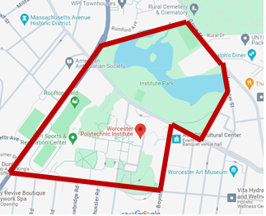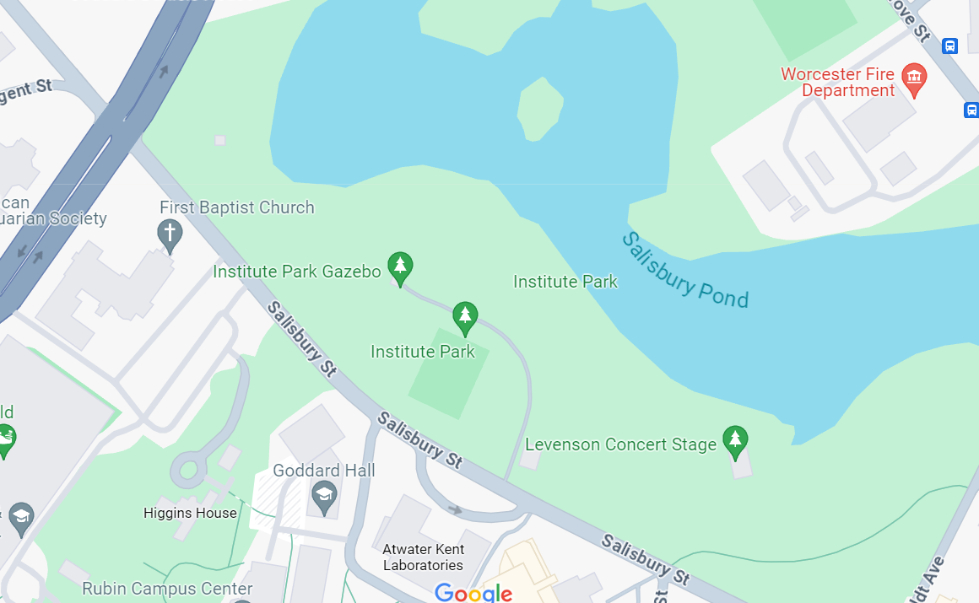

Chosen Site: Institute Park

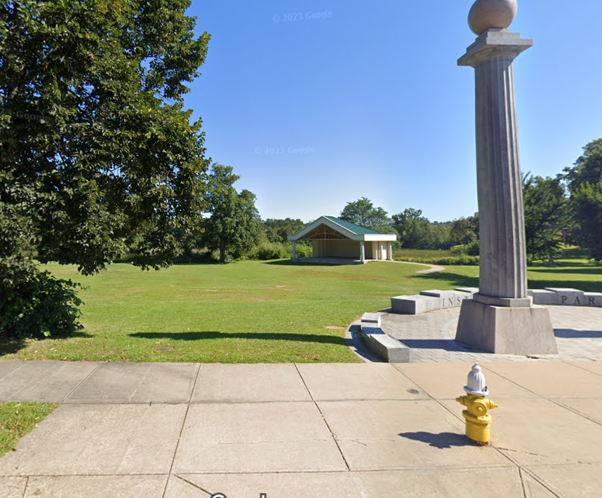

Institute Park has a large space for social events, and enough space to place the clay oven and it’s supporting structures with minimal complications. The park is within a 5-minute walking distance from campus, allowing easy access for both students and WPI staff. Easy access means increased use of the clay oven and speedy repairs as needed.

Below are images taken at Institute Park.

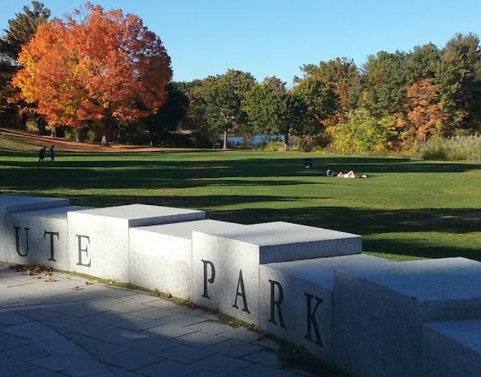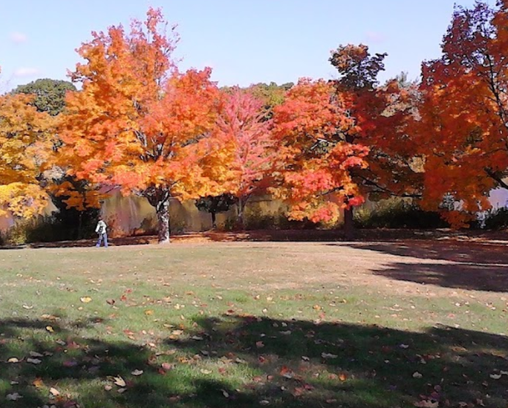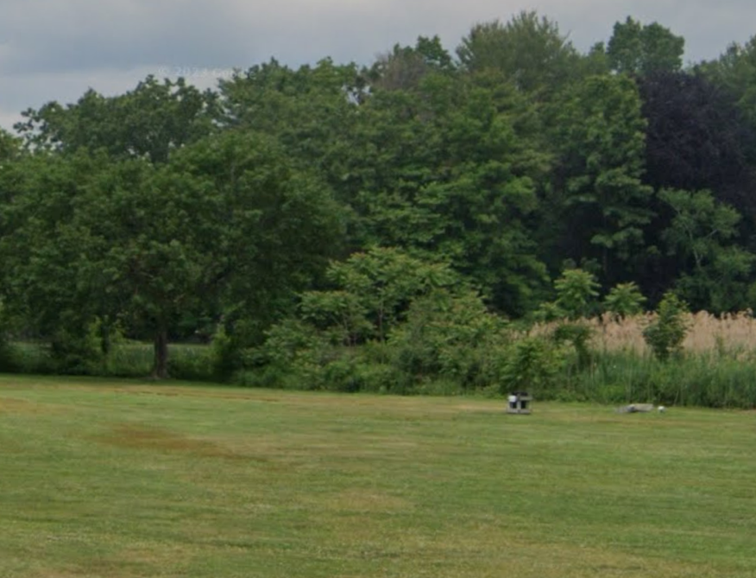

## Iteration 1

### Prototype

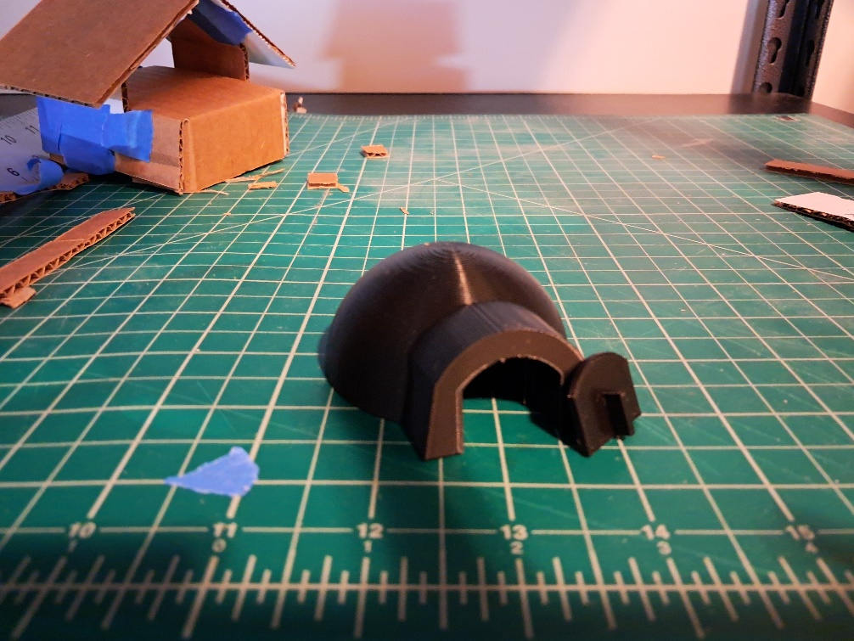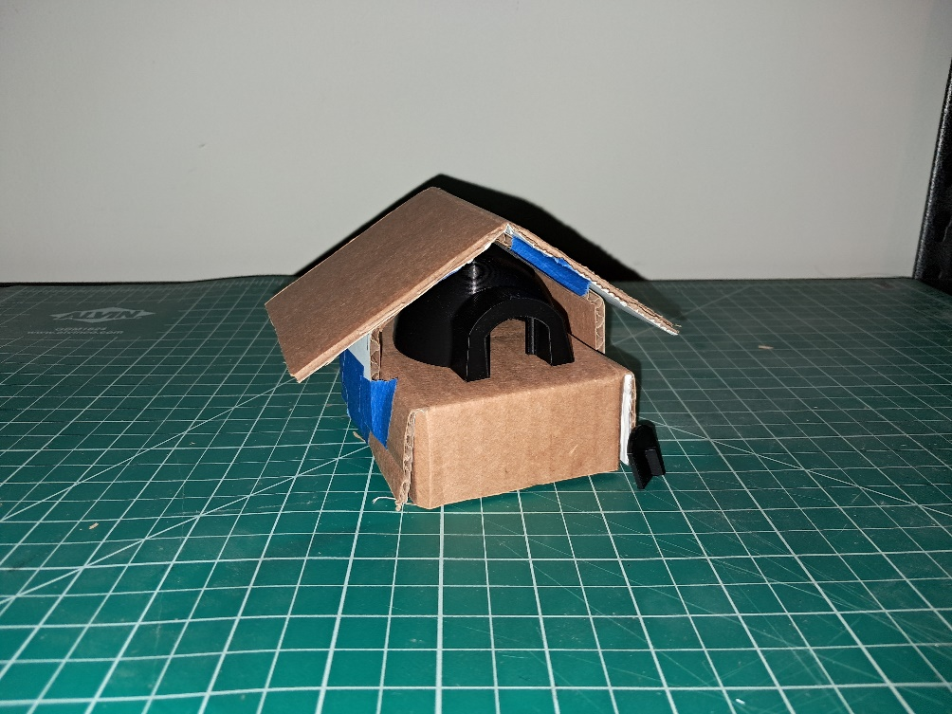

### Renders

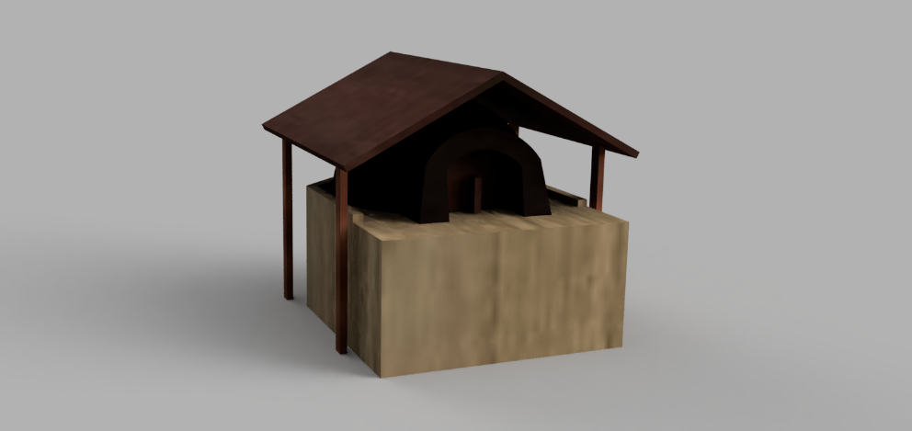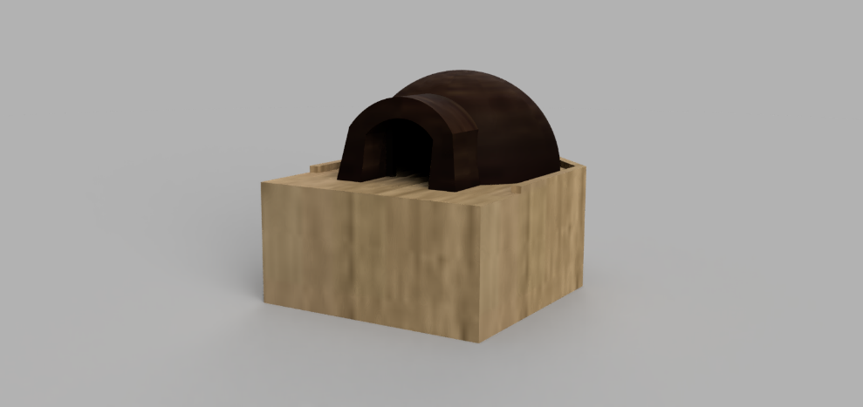

## Iteration 2

### Render

There was no renders of this iteration of the clay-oven project.

### Blueprint

The documents shown below detail the materials and dimensions of the clay oven. The following section shows the desired location for the clay oven.

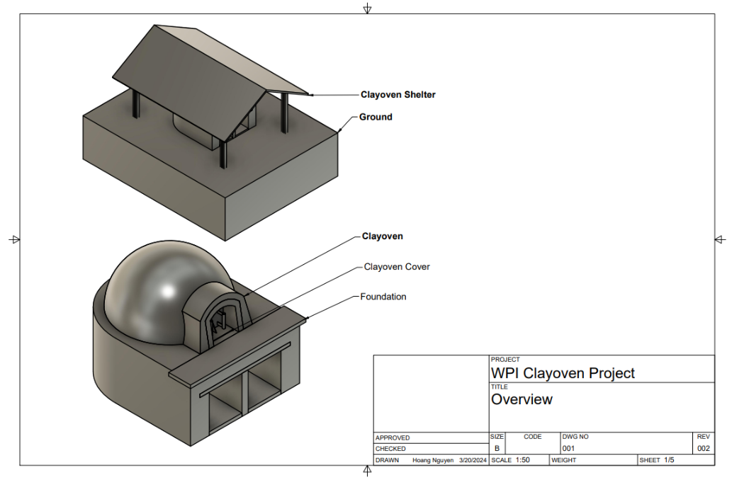

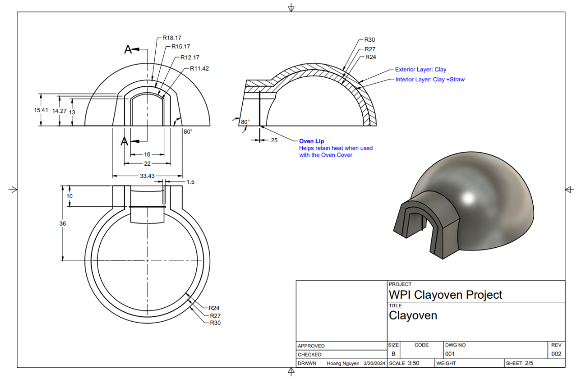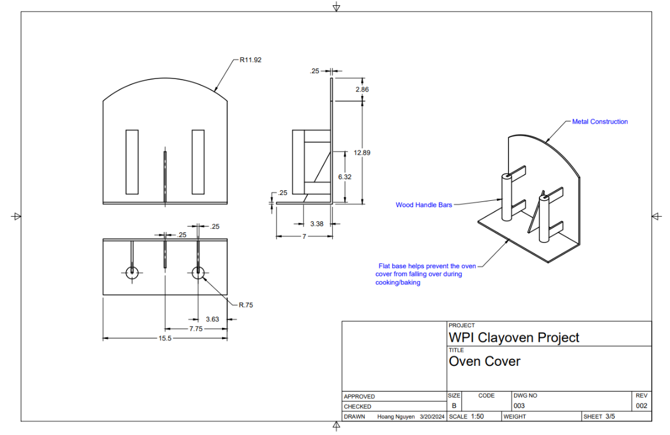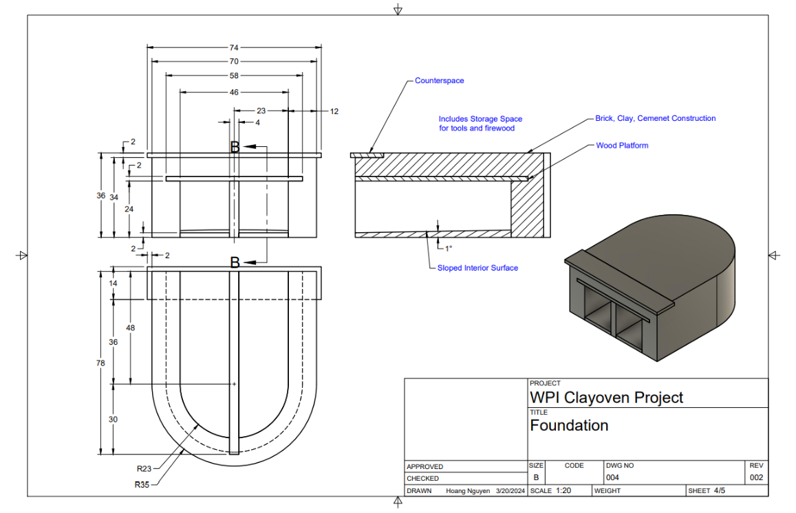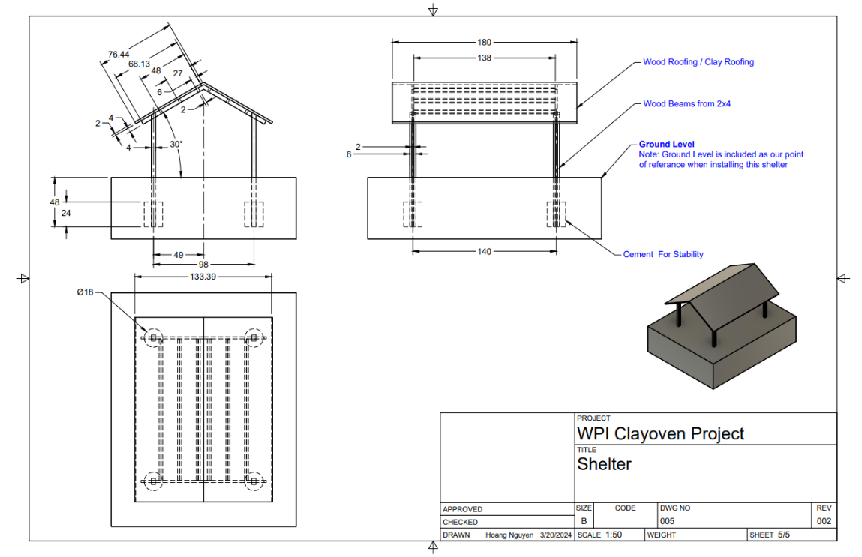

## Iteration 3 (Final)

### Render

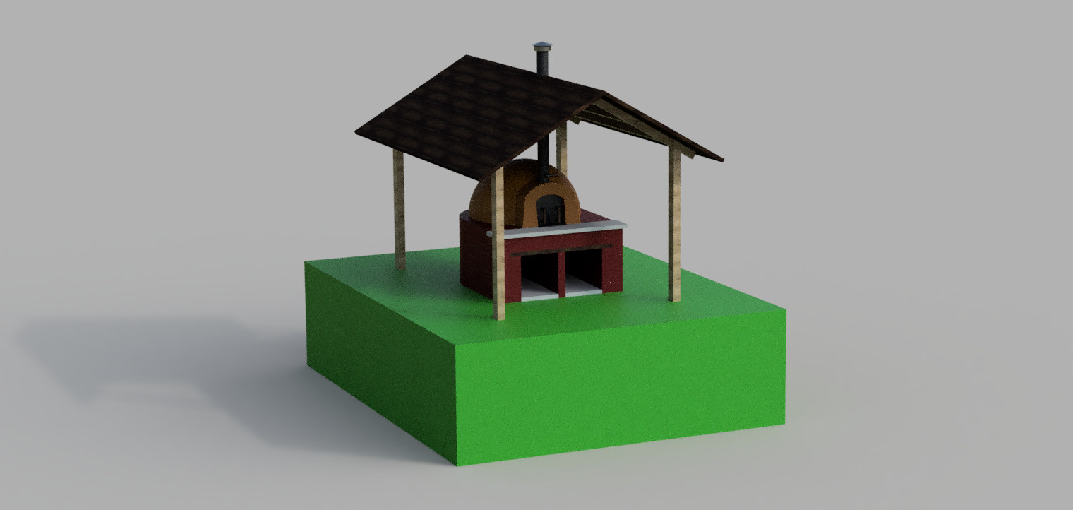

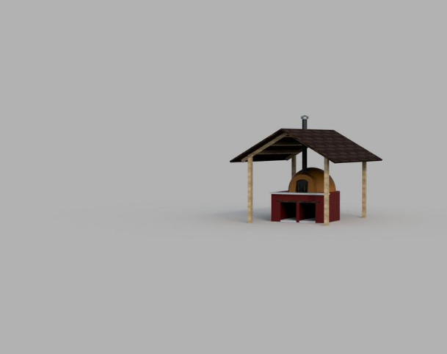

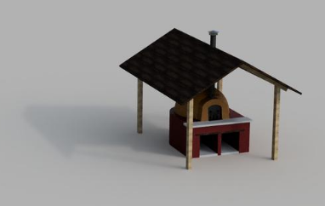

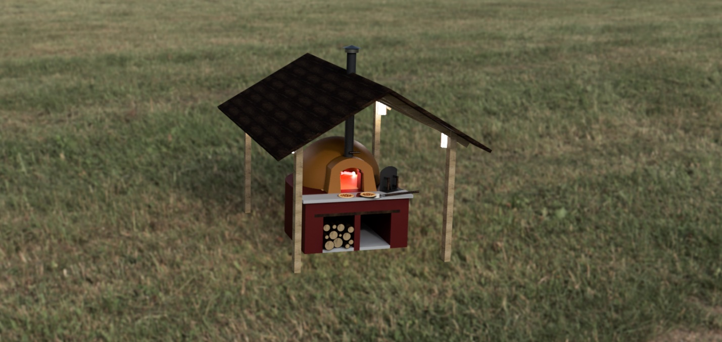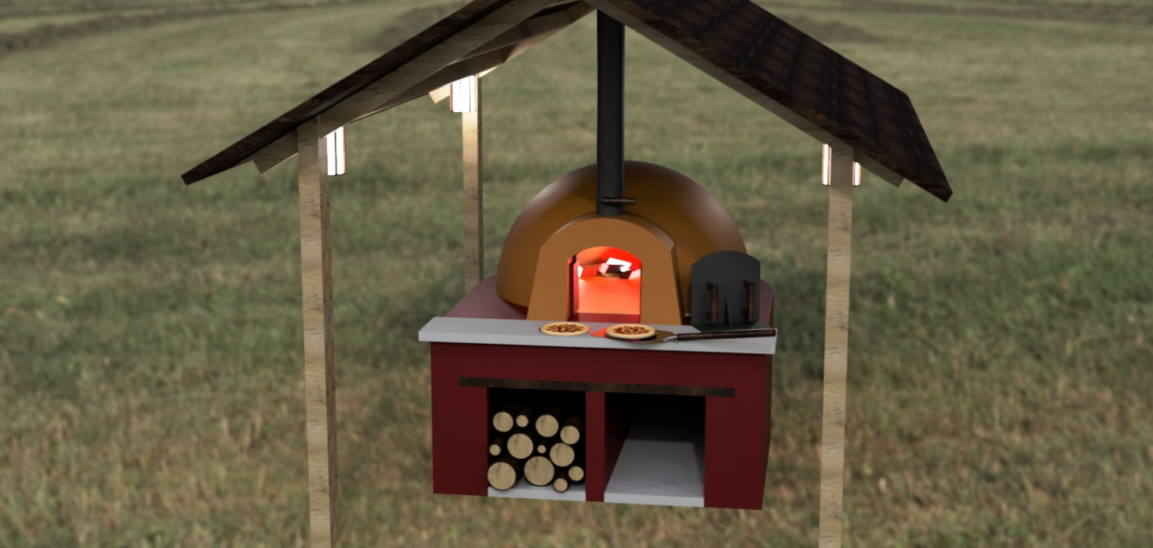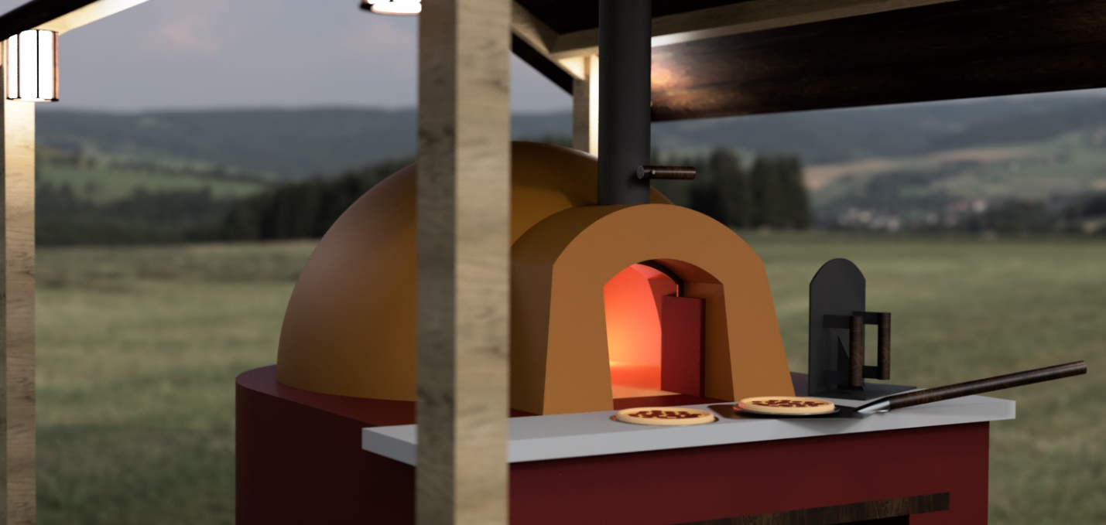

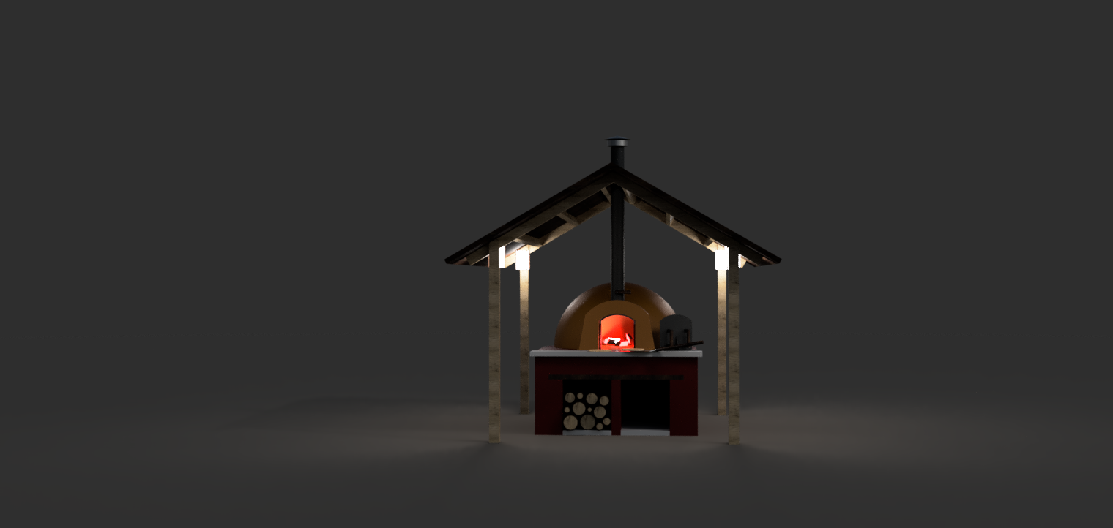

### Onsite Render

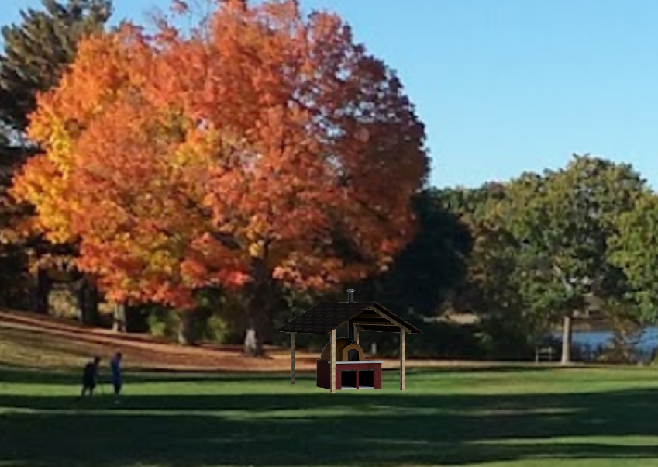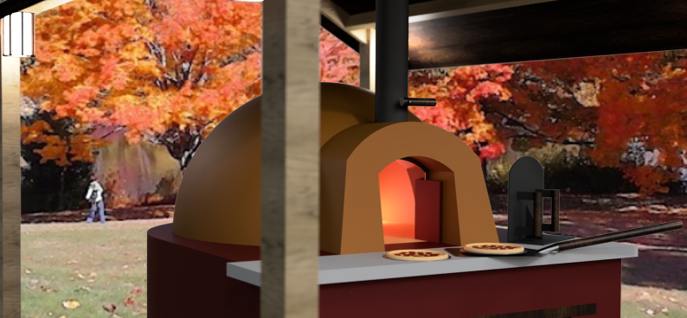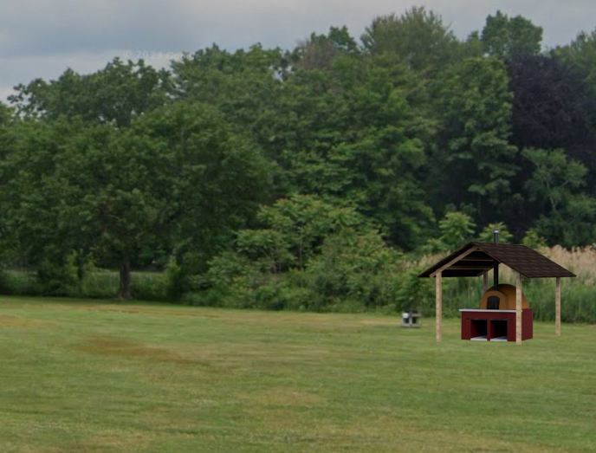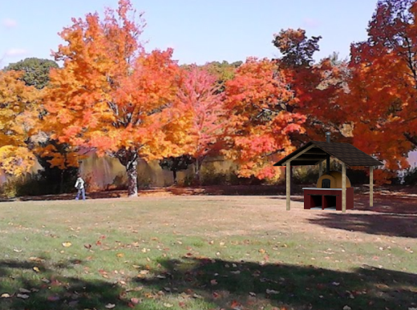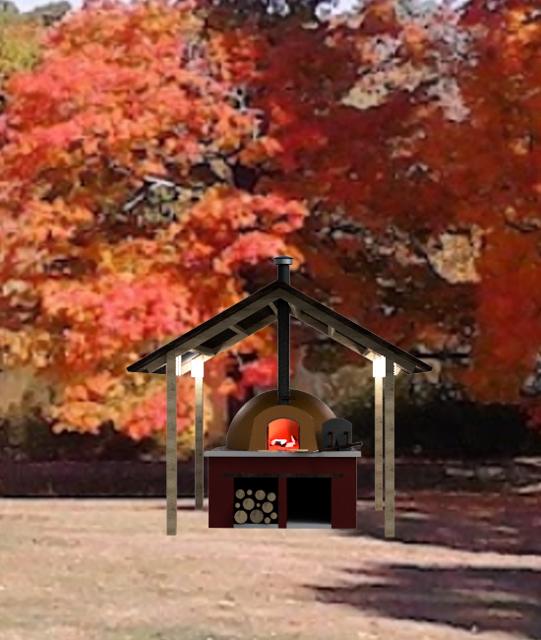

### Blueprint

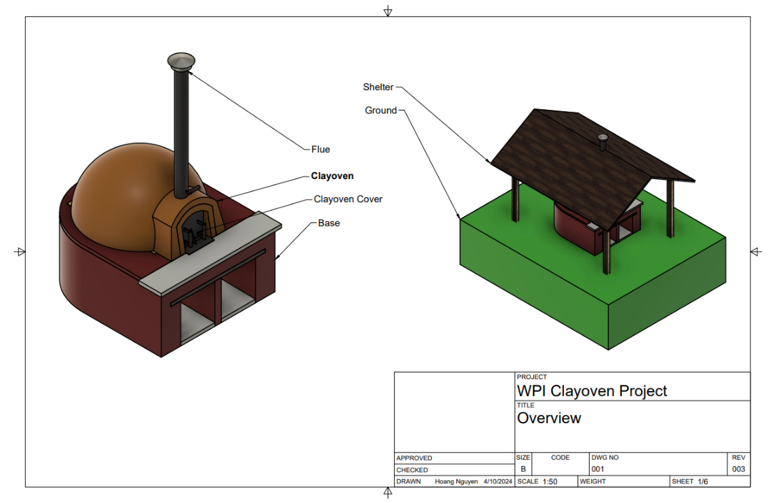

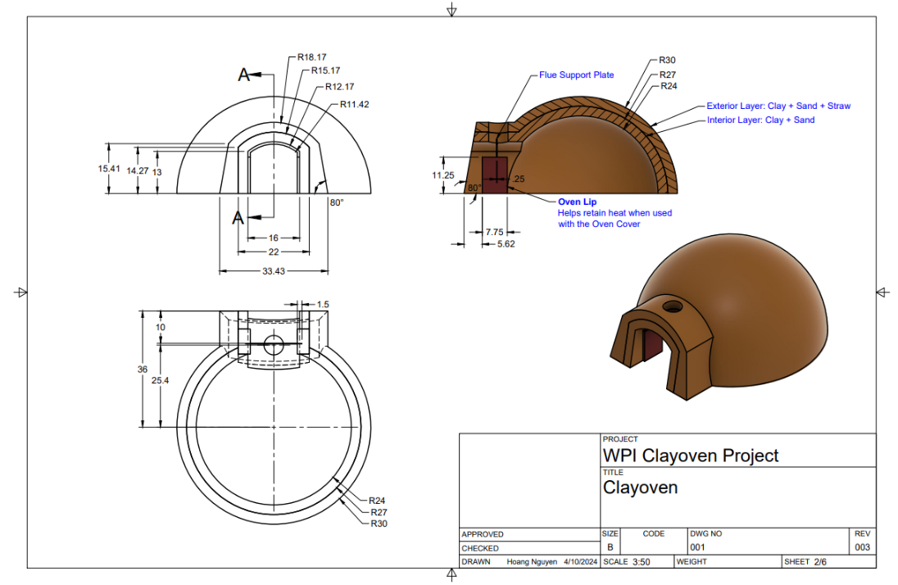

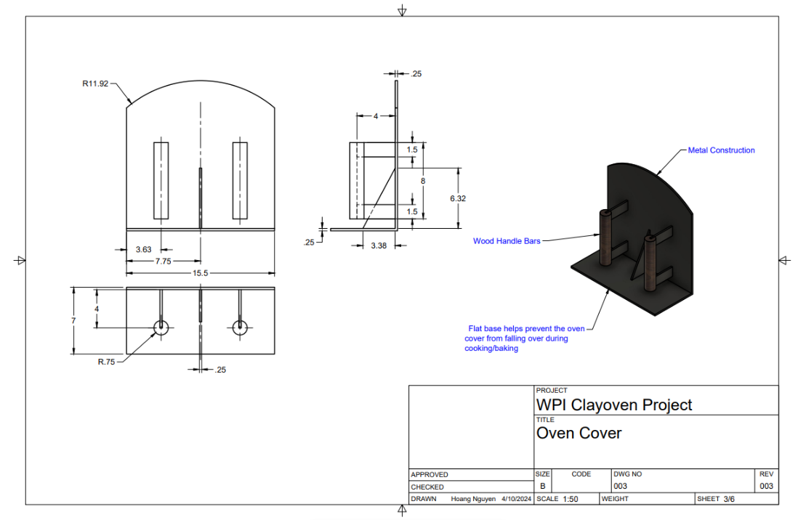

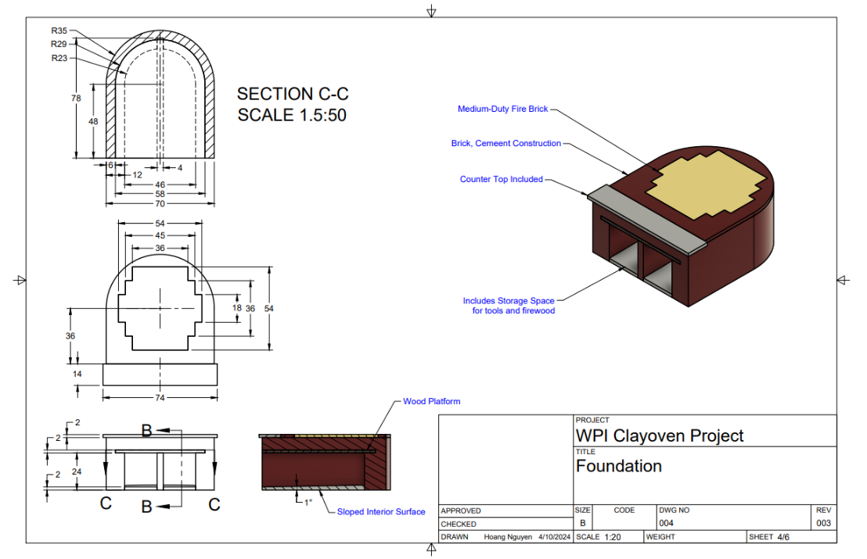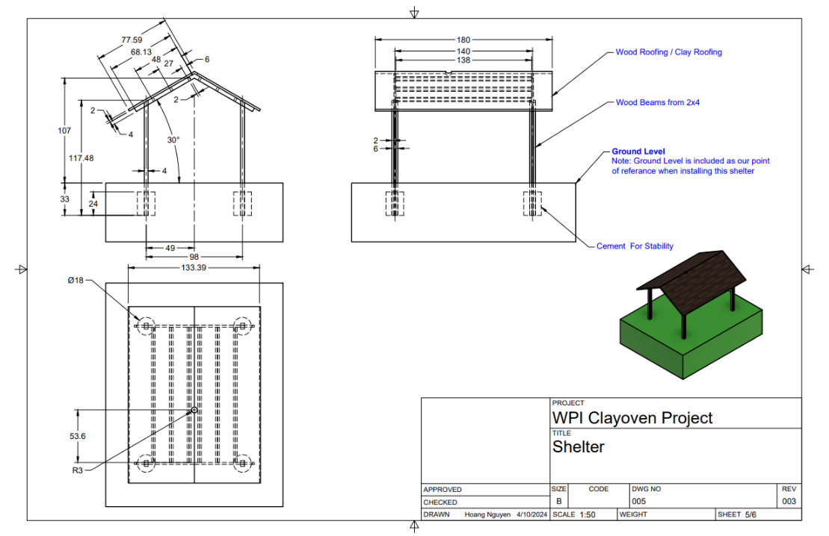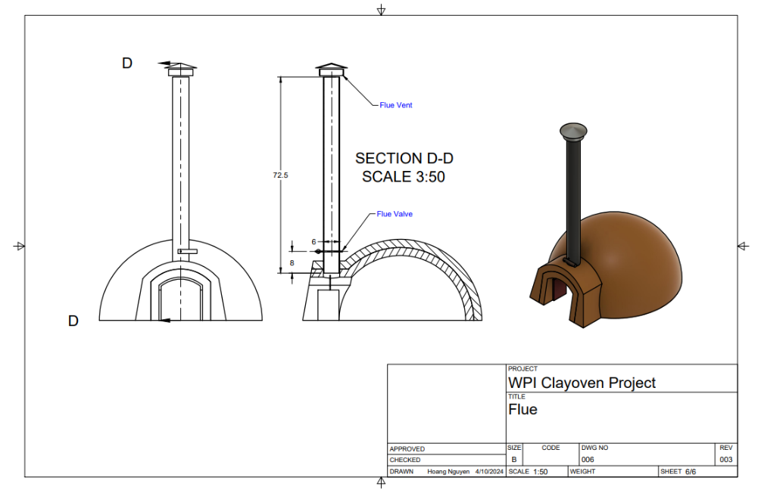

# Project Closure

The closing of this project indicates that it is ready to be presented to the class for the purposes of the design competition, via a recorded PowerPoint presentation. This closing is regarding the project management activities associated with the plan for building of the oven, not the actual construction of the oven. In closing this project, we summarize the requirements from “Smoky” and various project management activities we conducted (and will conduct through the oven’s construction and use) below.

|  |  |  |
| --- | --- | --- |
| **Project Requirement** | **How It Was Completed** | **Who Completed It** |
| Must be accepted by your client, Vance “Smoky” Wilson, who is the design competition* representative | A Project Overview Statement was built and approved by “Smoky” | Andrew |
| Must be capable of simultaneously baking two 10” round pizzas or roasting one 25# turkey | The oven was designed to be large enough to fit in the desired food items (see: Project Design Documents) | Hoang |
| Must be easy for novices to use; easy is defined as operations being explained in less than one page of instructions | The oven’s design is catered to the desired stakeholders, and surveys will be monitored to ensure ease-of-use. (see: Project Stakeholder Management) | Varun |
| Must burn seasoned hardwood to quickly heat (e.g., for pizza baking) to over 800° F (427° C) and efficiently retain heat (e.g., for overnight roasting); efficiency is essential for promoting the oven as a sustainable (green) design | The materials that were used that will be in contact with the heat (the flooring, the entrance cover, and the inner layer of the clay oven) can withstand 800 ° F. The insolation material (outer layer) can retain heat.  (see: Project Design Documents) | Hoang |
| Shell must be primarily built of non-commercial earth products (i.e., clay and sand); flooring and insulating materials/components may be of commercial or non-commercial origin. | The outer and inner layers of the clay oven are built with clay, sand, and straw. All other components are commercial products.  (see: Project Design Documents, Project Cost Management) | Hoang |
| Must be sited somewhere on the portion of the WPI campus that is bounded by Park Avenue, Salisbury Street, Boynton Street, and Institute Road or within Institute Park | Institute Park was chosen as the clay oven site.  (see: Project Design Documents) | Hoang |
| Must include design of and plans for constructing all supporting structures and accessories necessary to ensure permanence and utility of the oven; permanence is defined as lasting at least five years without needing renovation; utility is defined as the ability for users to perform all typical tasks involved in baking pizzas and breads and roasting large food items. | The shelter helps to keep the clay oven lasting for the 5-year duration. The clay oven entrance cover and flue are custom built, to help retain heat.  (see: Project Design Documents)  For pizza making, a pizza peel is added as a project cost.  (see: Project Cost Management) | Hoang |
| Must include design models, production prototypes, and other proofs-of-concept as specified in major deliverables, minor deliverables, and client change-orders. | See Project Design Documents | Hoang |
| Plan for construction to be completed for first use not later than November 1, 2024 |  | Jayesh |
| An executive summary of project features along with creative extensions. | See Project Executive Summary | All |
| Change controls were monitored, including changes from the client and stylistic changes from within the team. | See Project Integration Management | All |
| The project scope was defined, monitored, validated, and controlled | See Project Scope Management | Jayesh |
| The project schedule was defined, sequenced, built, and controlled to meet the necessary deadlines. | See Project Schedule Management | Jayesh |
| The project costs were defined, estimated, monitored, adjusted as needs changed, and controlled | See Project Cost Management | Mostly Hoang (materials), also Varun and Jayesh |
| The quality of this project was ensured through an effective quality management plan that was controlled throughout the project. | See Project Quality Management | Andrew, Jayesh and Varun |
| The resources in this project were managed to ensure effective time management, cooperation, and training | See Project Resource Management | Varun |
| The risks involved in this project were identified. Then, a qualitative and quantitative risk analysis was performed. Finally, risks responses were planned, and risks were monitored. | See Project Risk Management | Jayesh |
| The project was effectively communicated to stakeholders via brochures (including the change management regarding the brochure) | See Project Communications Management and Project Integration Management | All |
| Project related procurements were planned | See Planning Procurements | Jayesh |
| Stakeholders were identified and their engagement was ensured and planned for. | See Project Stakeholder Management | Varun and Jayesh |

Project References:

1. Simon. “Beware of the Clay!” *The Clay Oven*, 16 June 2014, clayoven.wordpress.com/2014/06/16/beware-of-the-clay/.
2. Bawa, V. “Safety Tips to Consider before Installing an Outdoor Pizza Oven in Your Backyard.” *House Digest*, House Digest, 11 June 2023,
3. Pye Barker Fire and Safety Inc. “7 Safety Concerns about Wood-Fired Ovens - Fire Safety.” *Fire Safety*, fire-safety.typepad.com/fire_safety/2016/11/pb_201611_restaurantsafety-woodfireovens-title-wood-fired-ovens-they-offer-a-certain-rustic-charm-and-when-we-occasionall.html. Accessed 12 Mar. 2024.
4. Wysocki, Robert K.. Effective Project Management: Traditional, Agile, Extreme, Hybrid (p. 128). Wiley. Kindle Edition.